

Individual Assessment Coversheet

To be attached to the front of the assessment.

**Campus:** Tygervalley **Faculty: IT** **Group:** 1

**Lecturer’s Name:** Mr. Shumba. S.

**Student Full Name:** Dylan Prinsloo

**Student Number:** CON-818152-L2T8

|  |  |  |
| --- | --- | --- |
| **Indicate** | **Yes** | **No** |
| Plagiarism report attached |  |  |

**Declaration:**

I declare that this assessment is my own original work except for source material explicitly acknowledged. I also declare that this assessment or any other of my original work related to it has not been previously, or is not being simultaneously, submitted for this or any other course. I also acknowledge that I am aware of the Institution’s policy and regulations on honesty in academic work as set out in the Eduvos Conditions of Enrolment, and of the disciplinary guidelines applicable to breaches of such policy and regulations.

|  |  |
| --- | --- |
| **Signature** DP | **Date** 00/00/0000 |

**Lecturer’s Comments:**

|  |
| --- |
|  |

|  |  |  |
| --- | --- | --- |
| **Marks Awarded:** |  | **%** |

|  |  |
| --- | --- |
| **Signature** | **Date** |

Eduvos (Pty) Ltd. (formerly Pearson Institute of Higher Education) is registered with the Department of Higher Education and Training as a private higher education institution under the Higher Education Act, 101, of 1997. Registration Certificate number: 2001/HE07/008

Section A

**Question 1**

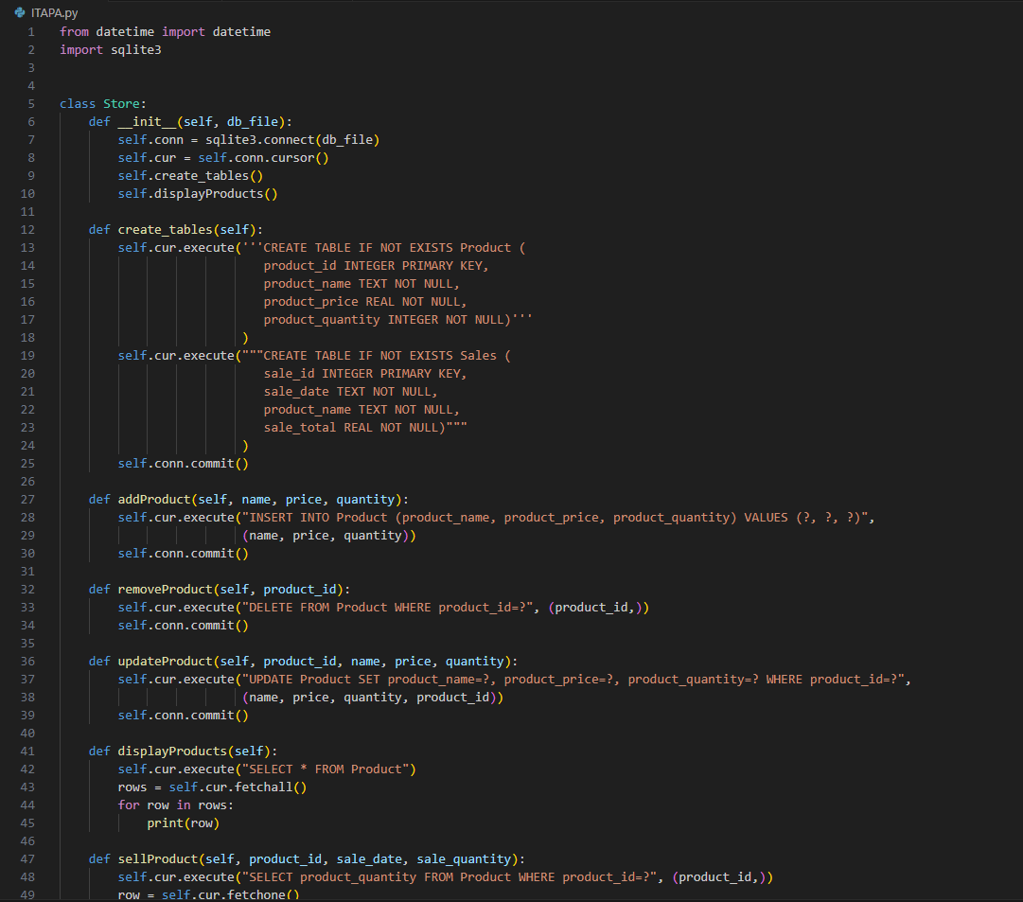

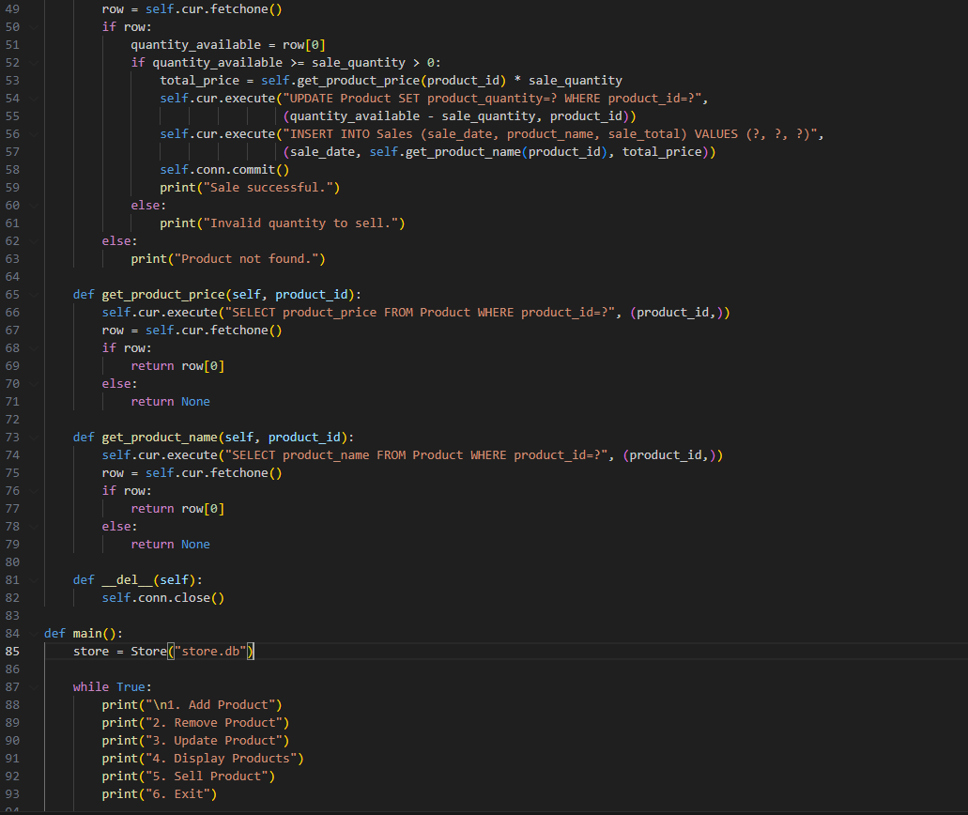

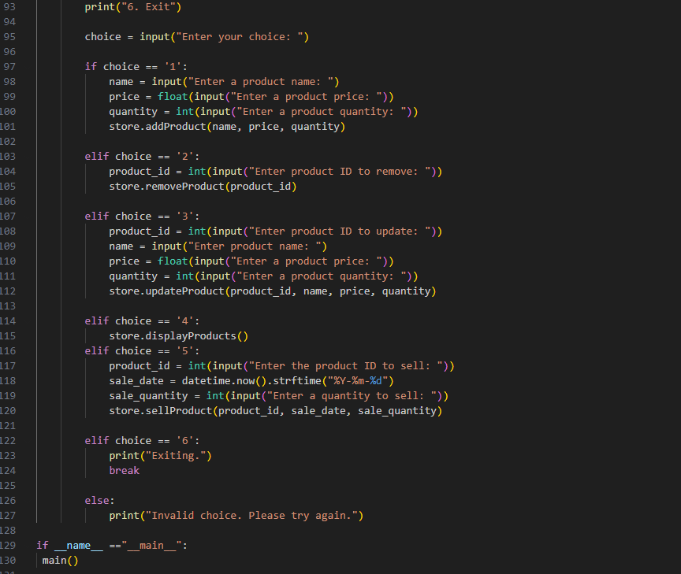

Output:

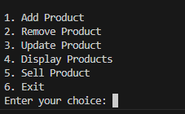

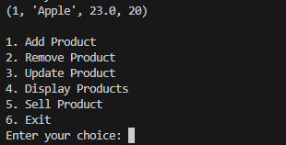

**Question 2**

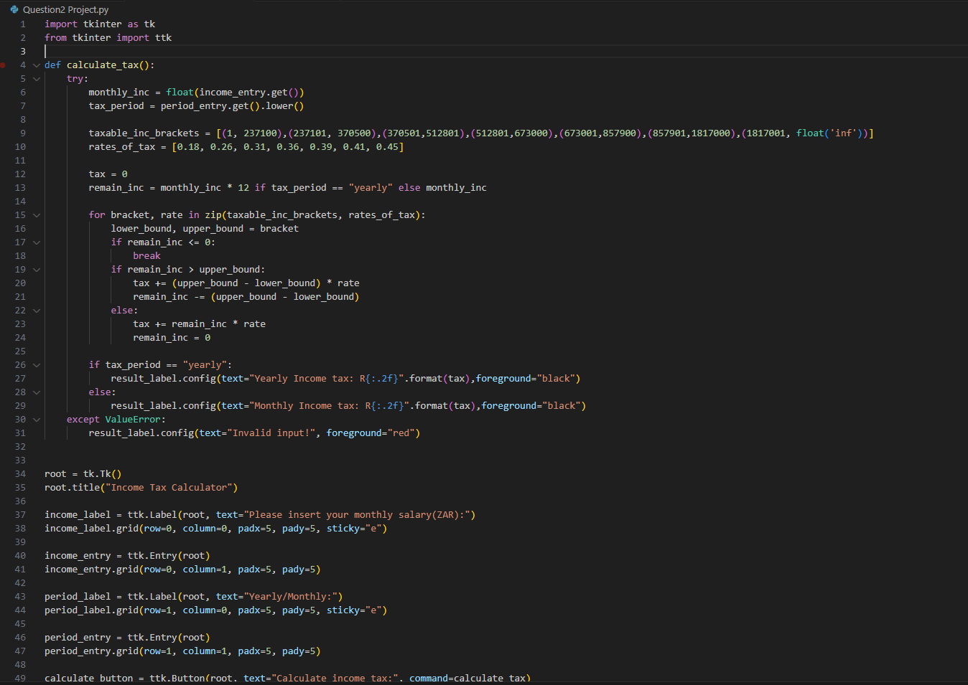

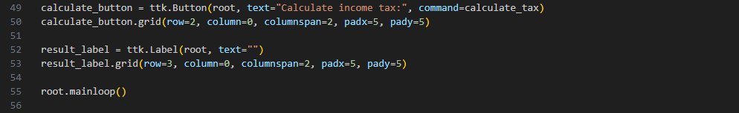

Output:

